CALL FOR APPLICATIONS FOR WOMEN OWNED AND WOMEN-LED E-COMMERCE BUSINESS SUPPORT

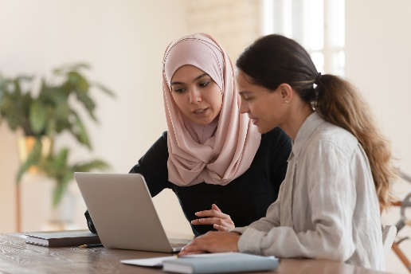
- Overview:

This project, Training of Female eCommerce Advisors for SMEs in Jordan, is part of the World Bank’s Women Entrepreneurs Finance Initiative (WEFI). The overall objective is to have a positive impact for local women-led businesses in the eCommerce space, enabling them to scale up, build their technical knowledge, and potentially enter new markets and export via eCommerce.

Specifically, the project aims to help women-led small and medium-sized Enterprises (SMEs) in Jordan to increase their sales via eCommerce by creating learning products relating to eCommerce.

We are calling for women-led SMEs who want to receive coaching and support from local and international experts to help them scale up their eCommerce sales.

We are seeking to support businesses that are women-owned or women-managed, who produce goods sellable through e-commerce platforms. We are particularly interested to work with companies in the Crafts, Beauty Products, Clothing and Food Products sectors, with between 5 and 50 employees. We are willing to consider smaller businesses, or those active in different sectors, if they demonstrate good potential for growth.

You do not have to have extensive previous experience selling online, but if you do, then we can help you improve and optimize your sales, and reach new potential markets.

Participating businesses will receive 3 - 4 practical coaching sessions from trained eCommerce advisors to cover all areas of running an eCommerce business. Coaching sessions are expected to be delivered virtually, and there will be a limited number of SMEs allocated to each eCommerce advisor to ensure a tailored coaching experience depending on your specific needs. During this time, our eCommerce advisors (supported by international experts) will continue to provide guidance, feedback and support to you to help you improve your skills and knowledge further.

The coaching will cover topics such as access to sales channels, using online payments, cross-border fulfilment, costs and digital marketing. After the successful completion of the coaching sessions, your staff will be knowledgeable on how to use eCommerce effectively and increase your online sales.

Participation in the coaching programme including the consultation will be subsidized by The World Bank Group and will cost $100 USD per company to participate.

- Benefits of Participation:
Businesses that are selected to participate in the coaching scheme can expect to gain a range of benefits, which will leave you in a strong position to upscale your operations and get hands on practical training and coaching on various areas of your business. These include:

- New practical skills – The coaching will cover hands on training of practical skills that will cover areas of the business such as marketing and fulfillment. With the small number of participants per trainer, we can tackle the personalized problems your business might be facing.
- Learning resources – You will receive learning materials from the coaching program which you will be able to refer back to, and reuse in the future.
- eCommerce Network – You will be able to build your professional network with local peers, international eCommerce experts, sales platforms, logistics providers, and payment platforms that in turn you can partner with and explore more business opportunities.
- Potential New Partners– You will have the opportunity to connect with new businesses in Jordan who could be your future partners.
- Discounted Rates - Participants will be able to access a number of exclusive benefits, such as preferential rates from shipping companies such as DHL
- Coaching to International Standards – You will be coached by locally based eCommerce advisors who have been recently trained on cutting edge ecommerce topics by internationally renowned eCommerce specialists, with many years of experience working in multiple markets.

The team of international specialists includes Fabian Staechelin, Bassil Eid, and Tamara Abdel-Jaber, as well as experts from OCO Global and Dajani Consulting, who are experienced supporting businesses in scaling up and internationalizing.

Fabian Staechelin is an eCommerce Expert who designed and launched the ITC-eBay partnership and rolled it out in Morocco in 2016, carrying out SME trainings in Casablanca. He has trained and onboarded dozens of women-led firms as consultant to ITC, and is now working with Nextrade on a virtual B2C eCommerce development project targeted at Brazilian firms to access a cross-border eCommerce training.
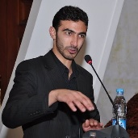
Bassil Eid is an experienced advisor to startups and entrepreneurs and an expert in eCommerce and logistics. He is a former eBay and DHL executive, with extensive contacts with marketplaces and logistics firms in the MENA region, including with a number of international logistics associations.

Tamara Abdel-Jaber is a Jordanian business leader who co-founded the Women in Business Arabia network, and since then it has grown organically to 40,000 members, many of whom are female business owners and professional women in Jordan. She

- Summary of key responsibilities:

Attendance of Online Coaching Sessions:
You will be expected to attend approximately 3-4 online practical coaching sessions over 2 weeks. The support will be delivered to businesses in three rounds between April and June 2021 – the exact dates and times of training will be confirmed at a later date.

Provision of Information and Data:
You will be to provide the programme team with feedback and some data relating to your sales of products via eCommerce channels, for the purposes of monitoring and assessing the success of the programme.

- Key Requirements for Participants:
We are looking for businesses who meet the following criteria:

Essential attributes:
- Women-owned (fully or partly) or women-managed business
- Small or Medium sized Business (between 5 and 50 employees)
- Some knowledge of eCommerce, retail, and selling online
- Interest & motivation to scale up the business
- Strong ability to use technology, including platforms such as Zoom and PayPal
- Strong language abilities in either English and Arabic
- Registered in Jordan
- Commitment to the program along with willingness to participate in surveys and share information about online sales to monitor and evaluate performance

Preferred attributes:
- Established businesses that have been operating for over 3 years
- Experience selling online via Social Media or eCommerce platforms

- More Information:
If you are interested in participating and would like more information, there will be an information session hosted by our lead partners OCO Global, which will give you an opportunity to hear more details about the course contents, ask questions, and meet the international trainers. You can access the session via the link below:

Date: February 24th 2021
Time: 12:00 Jordan Time
Register to attend:
https://www.eventbrite.co.uk/e/information-session-ecommerce-coaching-for-women-businesses-in-jordan-tickets-137345063783

The session will be recorded, and will be available to download after the above date via the following link:

https://www.dropbox.com/sh/suf7aacu930qysi/AAAbafL1gN3-lV8FmG3B2MGGa?dl=0
- How to Apply:
If you are interested in applying for this position, please go to the following link to fill out the application form and submit your CV (in English).

https://www.surveymonkey.com/r/WomenSMEJordan

The deadline for applications is 23:59 on March 4th 2021.

Shortlisted candidates will be contacted on a rolling basis, and will be informed of the next steps, which may require them to send further information or attend an online interview.

- Contact:
For any queries related to the above, please email us at the following address:

Contact Name: Osama Al Isawi
Company: OCO Global
E-mail: JordanEcommerce@ocoglobal.com

subject to confirmation

